Tordis Berstrand

University of Kent

**Jørn Utzon (1918-2008)**

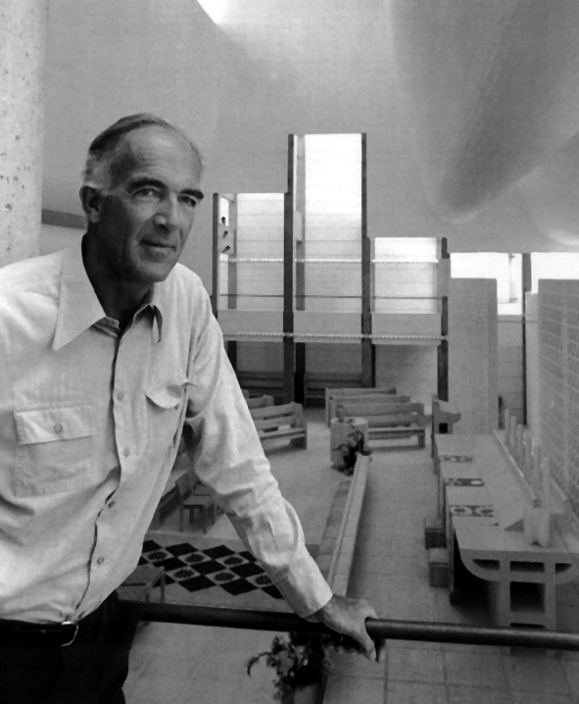

Jørn Utzon

<http://www.arc1.uniroma1.it/saggio/raccolta/6utzon/UTZO.jpeg>

The Danish architect Jørn Utzon, who grew up by the sea in northern Denmark, studied architecture at the Royal Danish Academy of Fine Arts, Copenhagen (1937-42). Tutors such as Steen Eiler Rasmussen gave Utzon’s early architectural approach a phenomenological angle, yet time spent in Stockholm working for GUNNAR ASPLUND during World War II would also be formative. After the war, extensive travelling facilitated a number of visits to high-profile international architects such as FRANK LLOYD WRIGHT and MIES VAN DER ROHE, and upon return to Copenhagen Utzon set up his own studio.

The early design for Hellebæk House (1952), the first known open-plan dwelling house in Denmark, saw the minimalism of Mies van der Rohe combined with Danish Modernism’s preference for yellow brick building. Following this, Utzon went on to develop a number of highly influential ‘dense-low’ housing projects such as the Kingo Houses, Elsinore (1956-60) and the Fredensborg Houses, Fredensborg (1962-65), while a concept of ‘Additive Architecture’ resulted in the catalogue housing project Espansiva (1968). During this time, Utzon embarked on the adventurous journey of the Sydney Opera House (1958-73) that would see his greatest contribution to architecture on an international scale take form.

Utzon’s conceptual competition winner, with its dynamically vaulted shell-structures over a podium base, proved challenging despite further detailing by the Danish engineer OVE ARUP. Utzon would eventually abandon the site after irresolvable disputes and local architects brought the building to completion. Included on Unesco’s World Heritage List in 2007, the opera house has, however, become an iconic landmark for Sydney and since 1998 it has been modernised following a manual produced by Utzon. The refurbished reception hall is accordingly renamed the Utzon Room and the architect was awarded the Pritzker Prize for the building in 2003.

Returning to Denmark in 1966, Utzon designed Bagsværd Church (1968-76) for a suburban site north of Copenhagen. The factory-like external appearance of the building with its prefabricated concrete panels and glazed tile cladding contrasts with the undulating, white-painted concrete roofscape within the main church room. The inwardness of the sky-lit interior and the industrial presence of the building’s repetitive structure unfold an ambiguity typical for Utzon’s architecture, the legacy of which lies in the dual approach of an almost poetic Nordic sensibility combined with cutting-edge 20th century engineering. The latter is not least inspired by childhood experiences of shipbuilding and naval architecture. Further to this, a marked concern with site-specificity and context, as seen in the two houses Utzon built for himself on Majorca (1970s/1990s), and a profound interest in nature’s organisational systems have contributed to the unique Modernism of the general oeuvre.

**List of works**

Melli Bank, Teheran, Iran, 1959

Project for Asger Jorn museum, Silkeborg, Denmark, 1963

Can Lis, Majorca, 1971-73

Kuwait National Assembly, Kuwait City, Kuwait, 1972-84

Paustian Furniture House, Copenhagen, Denmark,1985-87

Can Feliz, Majorca, 1991-94

Utzon Center, Ålborg, Denmark, 2008

**References and further reading**

Drew, P. (1995) *Sydney Opera House: Jørn Utzon*, London: Phaidon.

Møller, H. S. & Udsen, V. (2006) *Jørn Utzon: Houses*, Copenhagen: Living Architecture Publishing.

Utzon, J. (2004) *Jørn Utzon Logbook*, Hellerup: Edition Bløndal.

Weston, R. (2008) *Utzon: Inspiration, Vision, Architecture*, 2nd ed., Hellerup: Edition Bløndal.

**Visual material:**

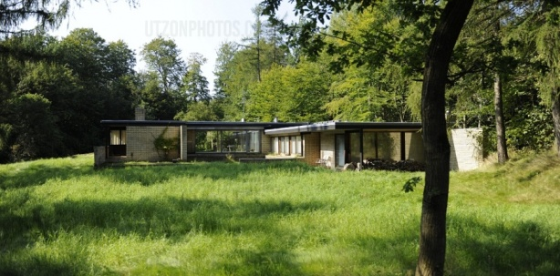 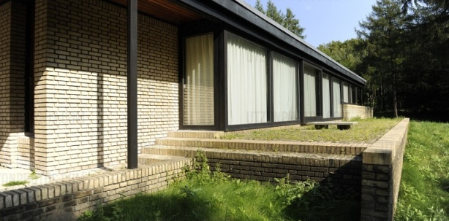

Hellebæk House, Hellebæk, 1952

Copyright: utzonphotos.com, <http://www.utzonphotos.com/utzons-projekter/arkitektens-hus-hellebaek/>

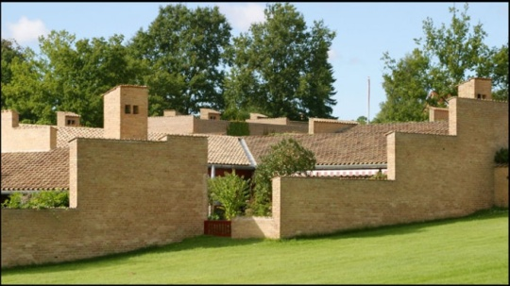 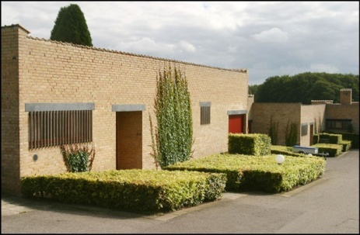

The Fredensborg Houses, Fredensborg, 1962-65

Copyright: arkitekturbilleder.dk, <http://www.arkitekturbilleder.dk/bygning-Fredensborghusene-307>

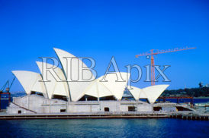 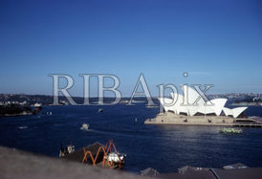

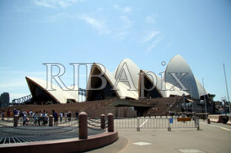 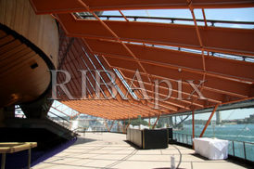

Sydney Opera House, Sydney, 1958-73

Copyright: RIBApix.com, <http://www.ribapix.com/index.php?a=advanced&s=item&key=XYToxOntzOjM6IjAwNCI7czo0OiI2MTEyIjt9&pg=1>

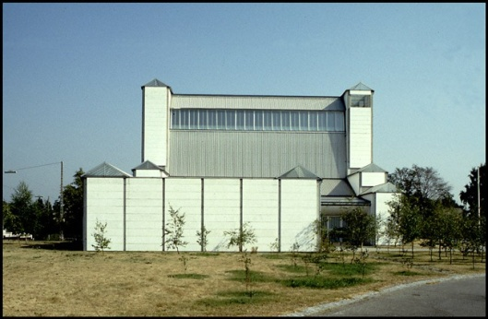 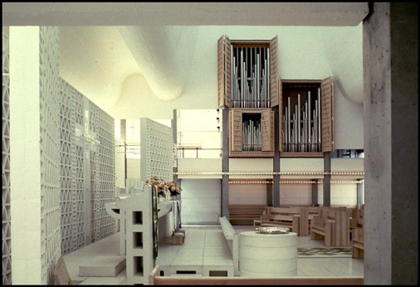

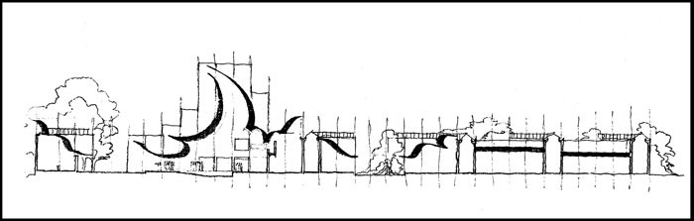

Bagsværd Church, Bagsværd, 1968-76

Copyright: arkitekturbilleder.dk, <http://www.arkitekturbilleder.dk/bygning-Bagsværd-Kirke-3>

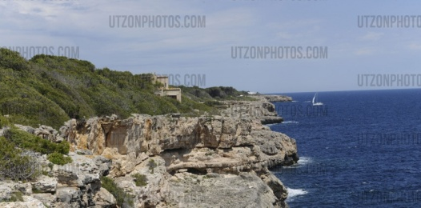 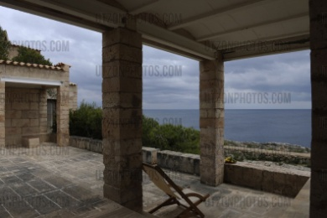

Can Lis, Majorca, 1971-73

Copyright: utzonphotos.com, <http://www.utzonphotos.com/utzons-projekter/can-lis/>

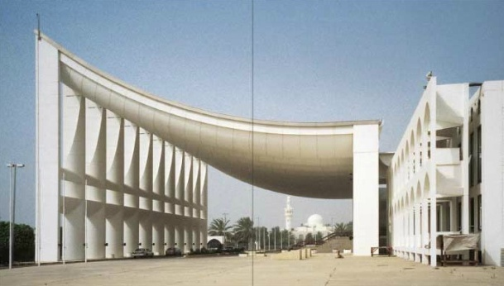 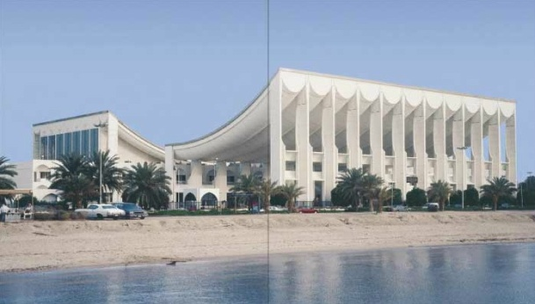

Kuwait National Assembly, Kuwait City, 1972-84

Copyright: Edition Bløndal, <http://www.edition-blondal.dk/logbook-iv/>